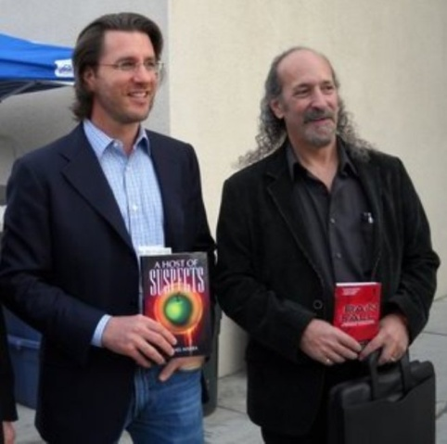
Authors Barry Eisler & Michael Marra-WINTER NATIONALS 2010
On December 4, 2010 the Winter Nationals were held in La Verne California. This well attended Tournament is hosted by Gary Goltz every year who is the President of the USJA. It is clear to all that he goes above and beyond to make this event a special one every time.
This year the Winter Nationals were proud to have in attendance two former Olympians in Jim Bregman and George Harris. Jim Bregman was also the first American to Medal in Judo and was also President of the United States Judo Association. George Harris was also a member of that Olympic team along with the Honorable Ben Nighthorse Campbell and Paul Maruyama. It should be noted that I was in correspondence with Ben Nighthorse Campbell and had extended an invitation to join his fellow Olympians. Unfortunately, he was just undergoing back surgery and could not attend. He did however ask me to convey to all his fellow Judoka his best wishes. I did so and would like to say to Ben that his brothers in Judo extended their warmest regards and best wishes for a healthy recovery.
It was my sincere privilege when asked to write this piece. This being especially so in that we had the honor of having in attendance the bestselling Author Barry Eisler. Barry was gracious to spend the entire day at the event and received so many people with his gracious style and warm smile. He proved to be a very genuine and humble man and it was our sincere pleasure to have him. By the way, if you have not read any of Barry Eisler’s books I implore you to do so as you will be entertained by a master that has you turning pages looking for more of his wonderful insight and knowledge that comes from a wide variety of personal experience blended with the characters he creates. Barry lived in Japan and studied at the Kodokan where he earned his Shodan. The USJA was proud to award him an honorary Nidan and Lifetime Membership. It should be noted that without the initiative and efforts of our Secretary Marc Cohen that the appearance of Barry Eisler would not have come to fruition.
As an author myself, it was my sincere privilege to meet and spend some time with Barry and we autographed our books for one another. Often times you do not expect what you receive and I can state that my personal experience with Barry was extremely rewarding not only for me but for all that I witnessed make his acquaintance. I can say without hesitation that the USJA is proud to have Barry Eisler not only as a member but as a friend!
With warmest regards I wish all a wonderful Holiday Season and a Happy and Healthy New Year!
Michael Lucadamo (Marra)
USJA Executive Assistant

